HACETTEPE UNIVERSITY
Department of Computer Engineering

Fuzzy Modelling
Laboratory

Furkan Simsekli
5th Semester
Turkey

Academic Year 2023/2024

Exercise 6

Write a script to calculate the probabilistic sum and Łukasiewicz sum of fuzzy sets A and B, which are described using Gaussian membership functions:

C1 – red Z1 – continous line
C2 – green Z2 – continous line
C3 – magenta Z3 – continous line
C4 – cyan Z4 – continous line, line character ,,d”
C5 – blue Z5 – continous line, line character ,,+”

DS = 0.2 R = [-14, 4]

Draw the membership functions μ_{A}(x), μ_{B}(x), μ_{C}(x), μ_{D}(x) and μ_{E}(x) on one graph in the range of R. Use the following colours μ_{A}(x) – C1, μ_{B}(x) – C2, μ_{C}(x) – C3, μ_{D}(x) – C4, μ_{E}(x) – C5, and continuous lines for each function and line characters Z1, Z2, Z3, Z4, Z5.

Sign the membership functions in the following way: μ_{A}(x) – MFA, μ_{B}(x) – MFB, μ_{C}(x) – MFC, μ_{D}(x) – MFD, μ_{E}(x) – MFE. Use a DS discretization step.

Write the equations describing the α-cut and the power of a fuzzy set. Determine the α-cut of the fuzzy sets: α-cut(D) for α=0.3 and α-cut(E) for α=0.5 and the power of the fuzzy sets: card(D), card(E).
Solution

% probabilistic sum and Łukasiewicz sum
x=[-14:0.2:4]
ya=exp(-(((x+3)/2).^2))
yb=exp(-(((x+6)/2).^2))
yc=exp(-(((x+9)/2).^2))
yd=ya+yb-ya.*yb
ydd=yd+yc-yd.*yc
ye=min(1,ya+yb)

% plot the curves
plot(x,ya,'r',x,yb,'g',x,yc,'m',
x,yd,'c-d',x,ydd,'y-d',x,ye,'b-+')
grid on
legend('MFA','MFB','MFC','MFD','MFDD','MFE')

% axis, line width, font size
set(gca,'fontsize',16)

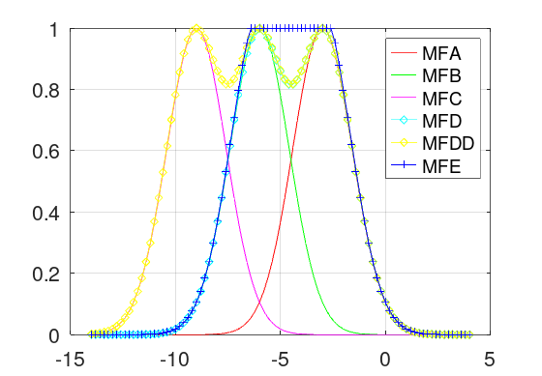
Figure 4.1: The membership functions MFA, MFB, MFC and the probabilistic sum MFD, MFDD and the Łukasiewicz sum MFE.

% alpha cuts
l03=x*0+0.3
l05=x*0+0.5

α-cut(D) for α=0.3
α-cut(D) = {-8.0, -7.8, -7.6, -7.4, -7.2, -7.0, -6.8, -6.6, -6.4, -6.2, -6.0, -5.8, -5.6, -5.4, -5.2, -5.0, -4.8, -4.6, -4.4, -4.2, -4.0, -3.8, -3.6, -3.4, -3.2, -3.0, -2.8, -2.6, -2.4, -2.2, -2.0, -1.8, -1.6, -1.4, -1.2 , -1.0}

α-cut(E) for α=0.5
α-cut(E) = {-7.6, -7.4, -7.2, -7.0, -6.8, -6.6, -6.2, -6.0, -5.8, -5.6, -5.4, ,-5.2, -5.0, -4.8, -4.6, -4.4, -4.2, -4.0, -3.8, -3.6, -3.4, -3.2, -3.0, -2.8, -2.6, -2.4, -2.2, -2.0, -1.8, -1.6, 1.4}

% calculate cardinal
cardD=sum(yd)
cardE=sum(ye)

card(D) = 31.380
card(E) = 33.058

